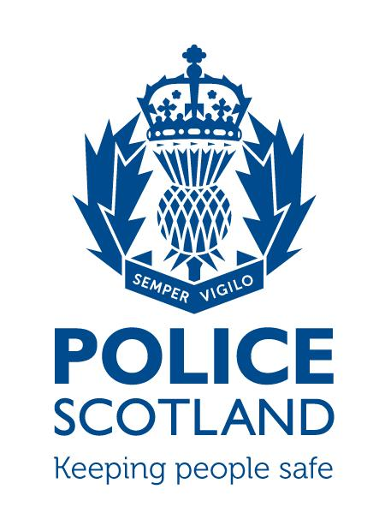

Tayside Division

Angus LPA

LPA Commander - Chief Inspector David McIntosh

LOCAL COMMUNITY POLICING AREA REPORT

Local Community Policing Area | Montrose and District:  TaysideMontroseDistrictCPT@Scotland.pnn.police.uk  Brechin and Edzell:  TaysideBrechinEdzellCPT@Scotland.pnn.police.uk
Local Area Inspector | Inspector Alice Coventry alice.coventry@scotland.pnn.police.uk)
Local Community Policing Team | Sergeant Clark Renilson (clark.renilson@scotland.pnn.police.uk)  Constable Ally Hutchison (alistair.hutchison@scotland.pnn.police.uk)  Constable Paul Conboy (paul.conboy@scotland.pnn.police.uk)  Constable Billy Rattray (billy.rattray@scotland.pnn.police.uk)

To be sent to the following Community Council email addresses on the 21st of each month outlining the previous month’s activity.

City of Brechin and District CC - eric.gray768@btinternet.com
Ferryden and Craig CC – gordoncbrown@talktalk.net - Chairman
gordie48@sky.com - Sec
Hillside, Dun and Logie Pert CC – teenrussell@yahoo.co.uk
Inveresk CC – wilson.claire@hotmail.co.uk
Montrose CC- ruttom26@aol.com
Communities – reidh@angus.gov.uk

PART A
NATIONAL AND LOCAL CAMPAIGNS AND MESSAGES
DRIVING WHIST USING A MOBILE PHONE/HANDHELD DEVICES

At 00:01hrs on Wednesday 1 March Regulation 110 of the Road Vehicles (Construction and Use) Regulations 1986 will be amended to increase the fixed penalty fine levels for road traffic offences involving the use of mobile phone and handheld devices.

This remains an endorsable offence and from the above date it will attract an increased penalty of 6 points and a £200 fine.

BOGUS CALLERS

There has been an increase in bogus callers in Scotland with an elderly couple in Montrose being targetted in the last week. These callers are presenting themselves as legitimate contractors who are offering to carry out work for the householder resulting in sub standard work some of which is not required in exchange for a costly bill. The more elderly and vulnerable in our communities are the main targets and it is important that we remain vigilant to such approaches. It might be a neighbour/friend or a family member so the message is to contact Police Scotland via 101 if any suspicions arise.

POLICE SURGERIES

The new community policing team are looking to increase police surgeries in both Montrose/Brechin and Edzell. Dates/times and locations will be advertised via social media and in the local press. This allows the public the opportunity to speak to their local community officers face to face and discuss any issues that they feel the police could assist with.

Recent crimes/issues in the area:
Brechin and District

During the period from 25/03/2017 – 24/04/2017 there has been 97 crimes reported in the Brechin area which cover a variety of incidents which is on average just over 3 per day. Included in these numbers are Vandalisms/Theft/Assault/Disorder/Drugs and Road Traffic Offences. With the A90 on Brechins doorstep the majority of these road traffic incidents are speeding offences and cover approx 30% of the total number.

There are no major issues relating to crime trends or patterns but there are still a small number of incidents relating to the persons entering sheds/garages overnight with the message being to make sure that all outbuildings are secure and items locked away.

As the light nights are slowly creeping in there is still an issue with a number of Youth related calls with the area of the public park/wards road being identified as the problem areas. These issues are being monitored with regular patrols being carried out in conjunction with engagement which is a key element to policing within the community.

Montrose and District

During the same period in Montrose and District there has been 75 crimes reported which again is an average of just over 2 per day. Again these incidents vary in content and follow the same pattern as Brechin.

A the light nights are slowly creeping in there is still an issue with a number of Youth related calls within John Street/Orange Lane/Murray Street/High Street being identified as the problem areas. These issues are being monitored with regular patrols being carried out in conjunction with engagement which is a key element to policing within the community.

With the annual MOFEST event only a few months away the police will be continuing to visit local licensed premises to review their plans for the event and to reiterate what is expected from them in line with legislation and the management of premises with the intention to work together to make sure the event is once again a success.

Road policing issues locally:
Parking offences: There is still an issue in the towns relating to vehicles being parked illegally. It is the intention of the new community policing team to carry out enforcement in an attempt to identify and deal with the persons involved and to aid the free flow of traffic and improve road safety.

As detailed in the local press there will be assistance provided by the local community wardens who are employed by the council and will be in the process of undergoing training with a target date of May having been identified.

Local initiatives:
The local community policing team in Montrose have been working with the primary schools to provide advice and guidance relating to road safety matters outside the schools. This consists of working with the heads and pupils who will monitor incidents relating to parking offences in restricted areas. It is intended to role this initiative out in Brechin also.

There has been two days of action carried out in Montrose Street Brechin with visits carried out to identified licensed premises/business premises and problematic flats. It is intended to continue this action in the future not only in Montrose Street but where specific problems have been identified within the community.

Forthcoming events in area (associated issues):
None at present

Other topics of note or messages:
COMMUNITY POLICING TEAM

Inspector Alice Coventry: alice.coventry@scotland.pnn.police.uk
Sergeant Clark Renilson: clark.renilson@scotland.pnn.police.uk
Constable Alastair Hutchison: alastair.hutchison@scotland.pnn.police.uk
Constable Paul Conboy: paul.conboy@scotland.pnn.police.uk
Constable Billy Rattray: william.rattray@scotland.pnn.police.uk

As the community policing team develops it is the intention to hold regular police surgeries in Montrose and Brechin which will be advertised in the local presss and via social media. We would like to encourage the local community to either attend or if they are not in a position to do so please feel free to use the contact email details provided above regarding any community issues.

PART B
Feedback from Community Council
(Issues raised worthy of police interest for feedback)
 | Issue of police interest raised | Raised by
1
2
3
4
5
6

7

8

PLEASE RETURN THIS FORM – to Local Community Policing Team

